**\*\*\*\*\*\*\*\*\*\*\*\*\*\*\*\*\*\*\*\*\*\*\*\*\*\*\*\*\*\*\*\*\*\*\*WEEK_7\*\*\*\*\*\*\*\*\*\*\*\*\*\*\*\*\*\*\*\*\*\*\*\*\*\*\*\*\*\*\*\*\*\***

**Topics:**

1. **Drawer Navigation**
2. **Recycler List View**

**1. Drawer Navigation**

I’ll make a drawer navigation bar in my developed android App i.e., Quiz_Box (our first assignment).

First create an assets folder in the project inside drawable.

***drawable>>new>>vector asset***

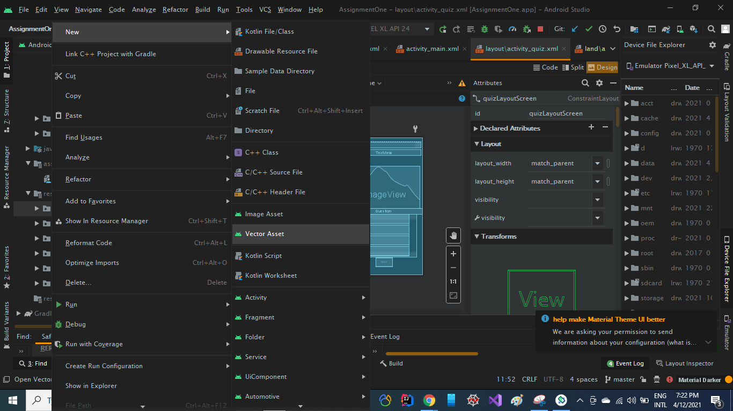

Then create a resource directory as  
 res>>new>>resource directory

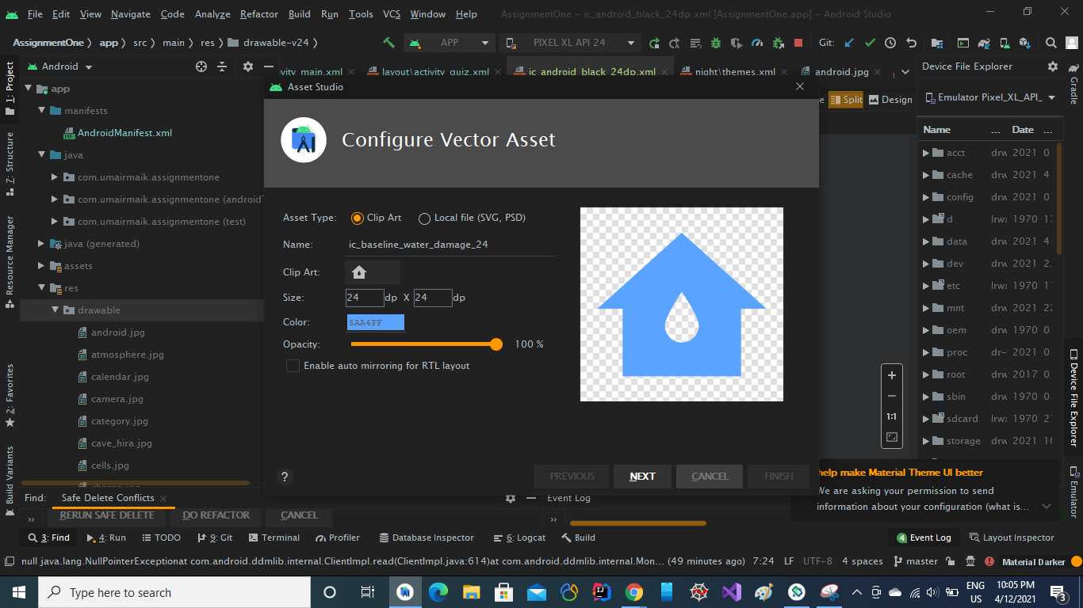

Select an icon from **clip art and press Next button.**

Now add a new resource directory for Menu of drawer.

**res>>new>>android resource directory**

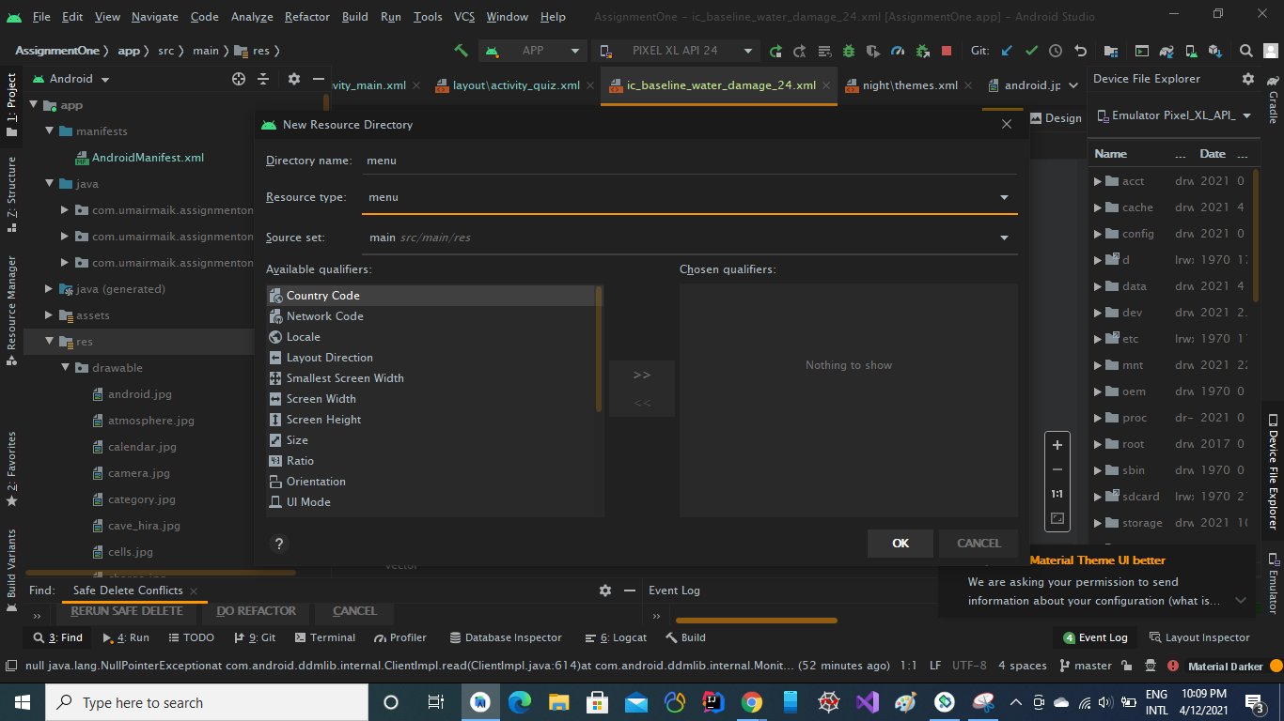

Now add new resource file in the above created directory

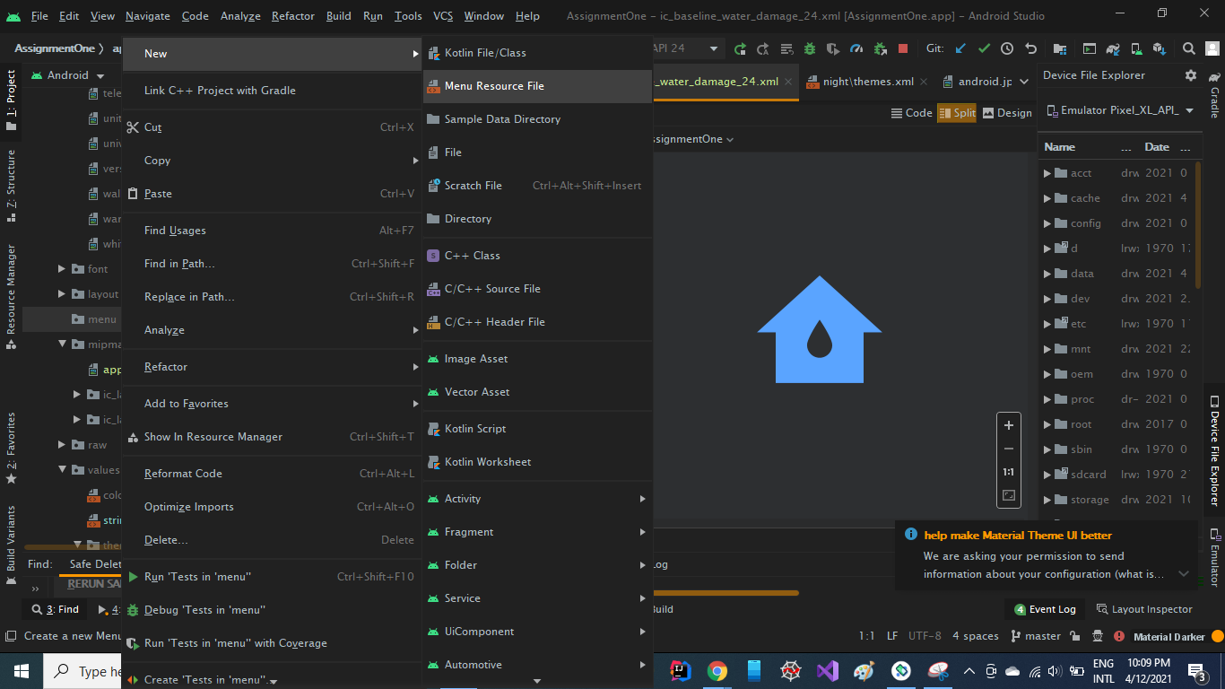

**Now we have following files available**

1. menu>>main_menu.xml

2. layout>>header.xml

Now we’ll add items in our main_menu.xml

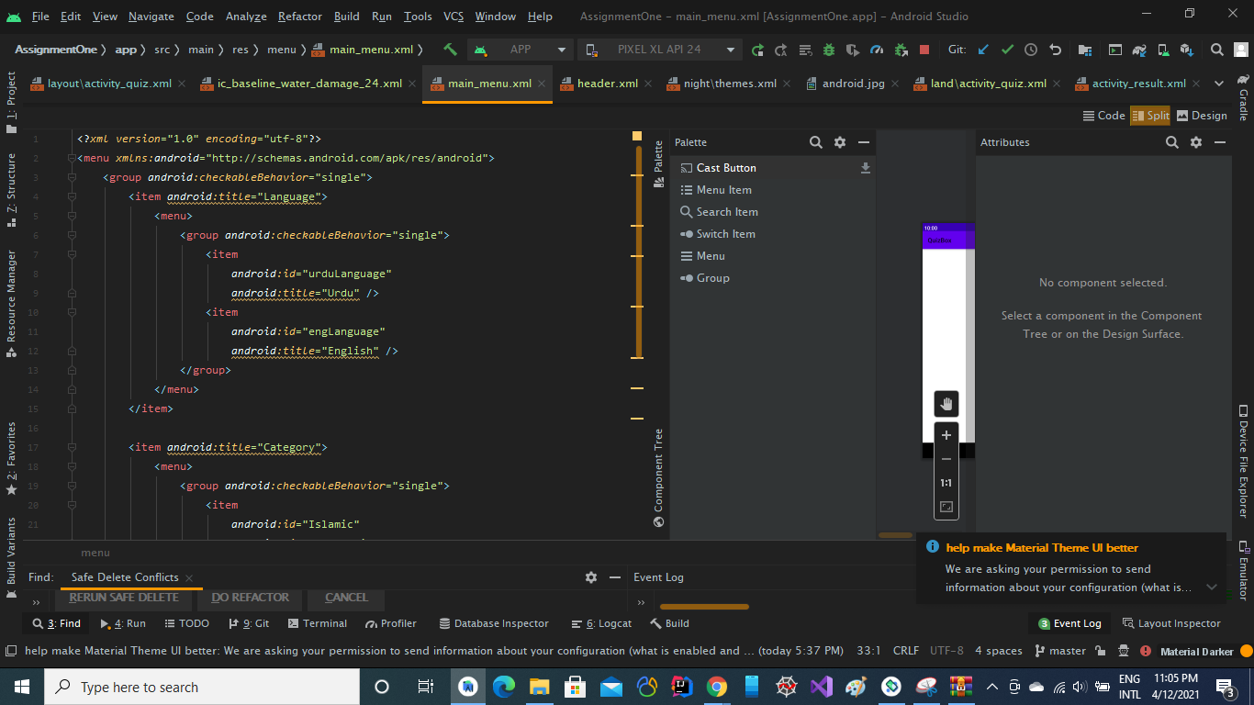

Here we have added two items which has further sub-items  
First is Language of App i.e., **English or Urdu**

Secondly, we have a menu of Quiz Category from where user will select what type of quiz he/she wants?

Now we’ll add data in our header.xml

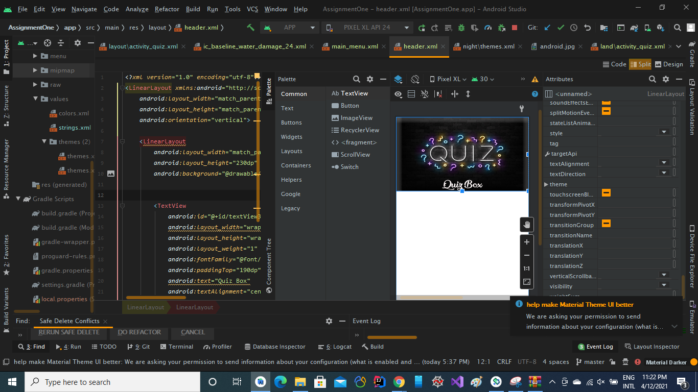

This is our haeder.xml file

Now we’ll add some project dependencies in our project.

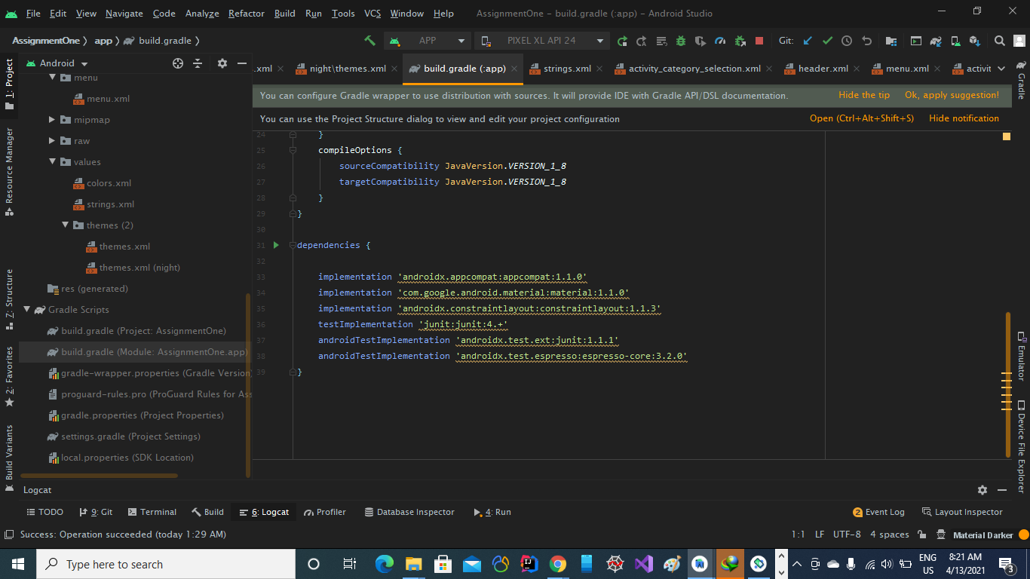

Now we have to merge our android drawer navigation to an activity

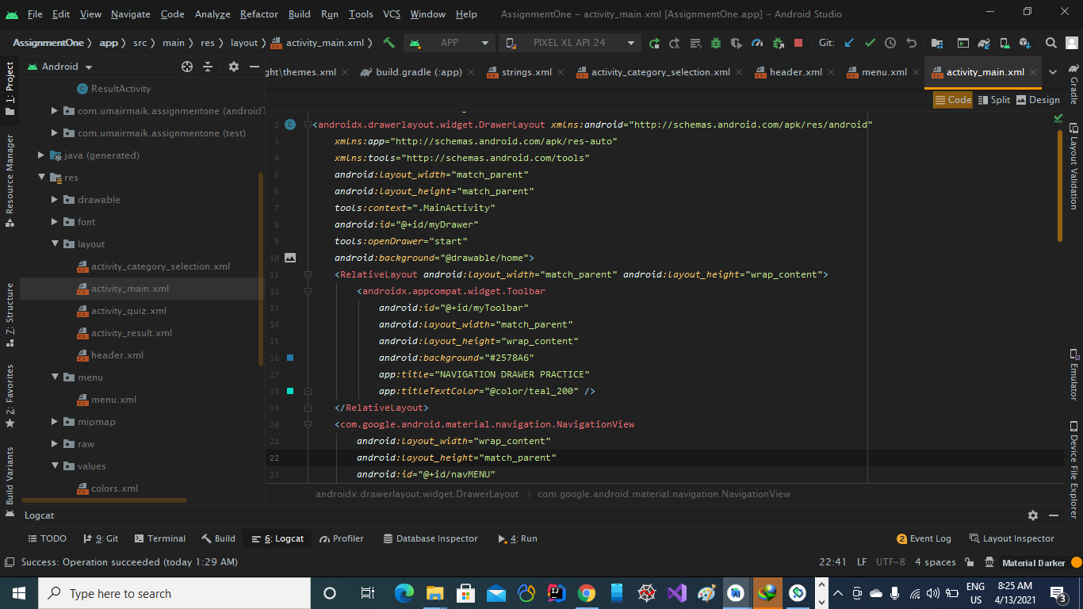

Now it is connected to our activity.

Now we have to set onClickLitsener.

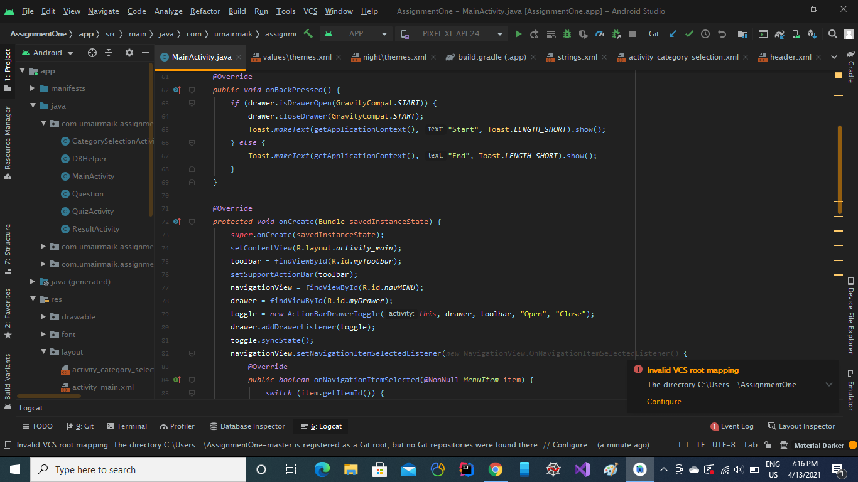

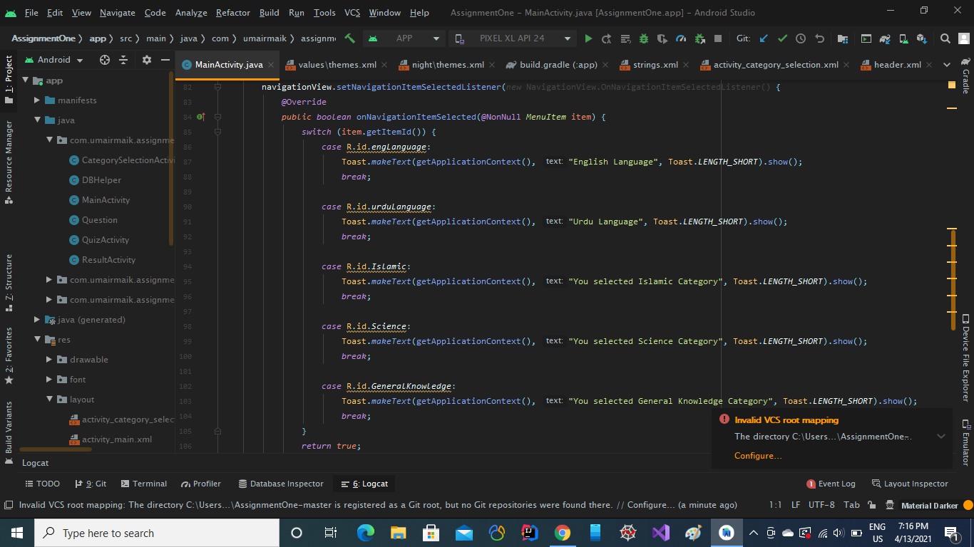

Now we are all set with our drawer navigation.

We can now do whatever we want in above case statements with our drawer items.

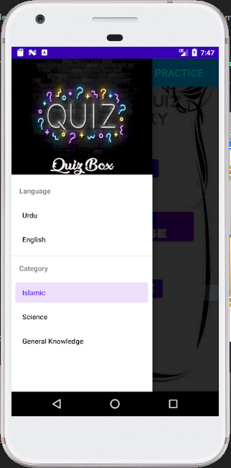



*********************************END************************************